**Ideation Phase**

**Define the Problem Statements**

|  |  |
| --- | --- |
| Date | 30 October 2025 |
| Team ID | NM2025TMID07475 |
| Project Name | Laptop Request Catalog Item |
| Maximum Marks | 2 Marks |

**Customer Problem Statement Template**

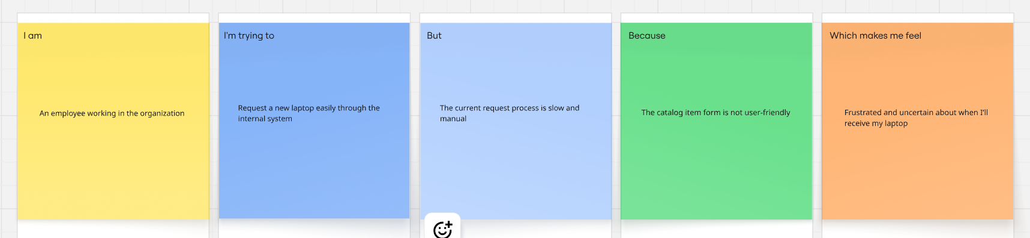

**Problem Statement Table**

|  |  |  |  |  |  |
| --- | --- | --- | --- | --- | --- |
| Problem Statement (PS) | I am (Customer) | I’m trying to | But | Because | Which makes me feel |
| PS-1 | an employee who needs a laptop for official work | request a laptop quickly through the catalog system | the approval process and delivery take too long | the process involves multiple manual steps and lacks automation | frustrated and unable to start my work on time |
| PS-2 | a new joiner who urgently requires a laptop | track the status of my laptop request easily | there is no transparent system to check progress or notifications | the platform doesn’t provide real-time updates or tracking visibility | anxious and uncertain about when I’ll receive my laptop |